Experiment No: 01
Experiment Name: Apply different noise types (Gaussian, Salt & Pepper) to an image and use the following filters to remove noise:
i) Mean Filter
ii) Gaussian Filter
Compare the effectiveness of each method. Which filter works best for which type of noise?

Objectives:
- To understand different types of image noise (Gaussian and Salt & Pepper).
- To simulate noise in digital images.
- To apply Mean and Gaussian filters for noise removal.
- To compare their effectiveness for different noise types

Theory:
Digital Image and Noise
A digital image is represented as a 2D matrix where each element (pixel) holds intensity values. During image acquisition, transmission, or processing, unwanted disturbances may affect pixel values—this is called noise.
Mathematically, a noisy image can be expressed as:
$$g(x,y)=f(x,y)+n(x,y)$$
Where:
- $f(x,y)$= original image
- $n(x,y)$= noise
- $g(x,y)$= noisy image

Types of Noise
1. Gaussian Noise
Gaussian noise follows a normal (Gaussian) distribution, meaning most noise values are small, while large deviations are rare.
Probability density function (PDF):
$$P(x)=\frac{1}{\sqrt{2πσ^{2}}}e^{-\frac{\left(x − μ)^{2}\right.}{2σ^{2}}}$$
Where:
- $μ$= mean
- $σ$= standard deviation
Characteristics:
- Affects every pixel
- Smooth variation
- Common in sensor noise

2. Salt & Pepper Noise
Also called impulse noise, it randomly replaces pixels with extreme values:
- Salt → white pixels (255)
- Pepper → black pixels (0)
Characteristics:
- Appears as scattered dots
- Caused by transmission errors or faulty sensors
- Not continuous like Gaussian noise
Image Filtering
Filtering is used to remove noise by modifying pixel values using neighboring pixels.

Mean Filter (Averaging Filter)
The Mean filter replaces each pixel with the average of its neighborhood values.
Mathematical representation:
$$g(x,y)=\frac{1}{mn}\sum_{(s,t)∈S}{f(s,t)}$$
Where:
- $S$= neighborhood window (e.g., 3×3 or 5×5)
- $m×n$= size of kernel
Working Principle:
- Slides a window across the image
- Computes average intensity
- Assigns average to center pixel
Advantages:
- Simple and fast
- Reduces Gaussian noise
Disadvantages:
- Blurs edges
- Not effective for impulse noise

Gaussian Filter
Gaussian filter uses a weighted average, where closer pixels have higher importance.
Gaussian kernel:
$$G(x,y)=\frac{1}{2πσ^{2}}e^{-\frac{x^{2}+y^{2}}{2σ^{2}}}$$
Working Principle:
- Uses Gaussian distribution for weights
- Central pixels contribute more
- Smoothens image while preserving edges
Advantages:
- Better than Mean filter
- Reduces Gaussian noise effectively
- Preserves edges relatively well
Disadvantages:
- Still not ideal for Salt & Pepper noise

Code:
import cv2
import numpy as np
import matplotlib.pyplot as plt

# Load image
img = cv2.imread('image.jpg')
img = cv2.cvtColor(img, cv2.COLOR_BGR2RGB)

# Function to add Gaussian noise
def add_gaussian_noise(image):
mean = 0
sigma = 25
gaussian = np.random.normal(mean, sigma, image.shape).astype('uint8')
noisy = cv2.add(image, gaussian)
return noisy

# Function to add Salt & Pepper noise
def add_salt_pepper_noise(image):
noisy = np.copy(image)
prob = 0.02

# Salt
num_salt = np.ceil(prob * image.size * 0.5)
coords = [np.random.randint(0, i - 1, int(num_salt)) for i in image.shape]
noisy[tuple(coords)] = 255

# Pepper
num_pepper = np.ceil(prob * image.size * 0.5)
coords = [np.random.randint(0, i - 1, int(num_pepper)) for i in image.shape]
noisy[tuple(coords)] = 0

return noisy

# Add noise
gaussian_noisy = add_gaussian_noise(img)
sp_noisy = add_salt_pepper_noise(img)

# Apply filters
mean_gaussian = cv2.blur(gaussian_noisy, (5,5))
mean_sp = cv2.blur(sp_noisy, (5,5))

gauss_gaussian = cv2.GaussianBlur(gaussian_noisy, (5,5), 0)
gauss_sp = cv2.GaussianBlur(sp_noisy, (5,5), 0)

# Show results
titles = ['Original', 'Gaussian Noise', 'Mean Filter', 'Gaussian Filter',
'Salt & Pepper Noise', 'Mean Filter', 'Gaussian Filter']

images = [img, gaussian_noisy, mean_gaussian, gauss_gaussian,
sp_noisy, mean_sp, gauss_sp]

plt.figure(figsize=(12,8))
for i in range(len(images)):
plt.subplot(3,3,i+1)
plt.imshow(images[i])
plt.title(titles[i])
plt.axis('off')

plt.tight_layout()
plt.show()

Output:
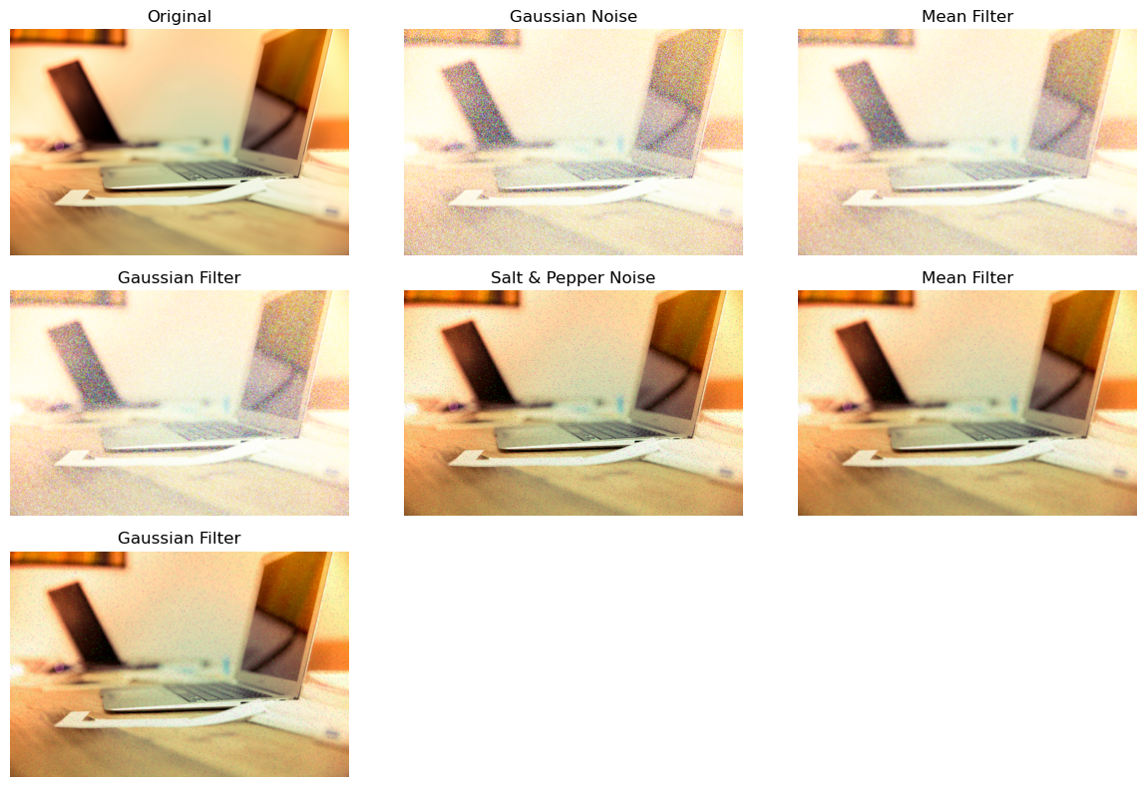

Results and Discussion:

Noise Type | Filter: Mean (Box) | Filter: Gaussian
Gaussian Noise | Good reduction, but significant blurring of edges. | Best Result. Effectively smooths noise while maintaining better edge definition.
Salt & Pepper | Poor. It smears the black/white dots into grey patches. | Poor. It blurs the noise but does not remove the impulse spikes.

Findings:
- Gaussian Noise: Both filters perform reasonably well because Gaussian noise is "additive" and distributed. However, the Gaussian Filter is superior because it respects the spatial relationship of pixels, resulting in a cleaner image with less "smudging" than the Mean filter.
- Salt & Pepper Noise: Neither of these linear filters is particularly effective. The Mean and Gaussian filters take the extreme values (0 or 255) and average them into the neighborhood, creating "smudges."
  - Note: A Median Filter (non-linear) would be the ideal choice for Salt & Pepper, though it was not requested in this specific task.

Conclusion
The Gaussian Filter is the most effective method for removing Gaussian Noise. For Salt & Pepper Noise, linear filters like Mean and Gaussian are generally ineffective as they fail to eliminate the outliers, instead spreading them across the image

Experiment No: 02
Experiment Name: Perform histogram equalization on a low-contrast image.
i) Compare the histogram before and after equalization.
ii) How does histogram equalization affect image brightness and contrast?

Objectives
- To understand histogram equalization in image processing.
- To enhance contrast of a low-contrast image.
- To compare histograms before and after equalization.
- To analyze the effect on brightness and contrast.

Theory

Image Contrast
Contrast refers to the difference in intensity between the darkest and brightest regions of an image.
- Low-contrast image: Pixel values are concentrated in a narrow range → image looks dull.
- High-contrast image: Pixel values spread across full range → image looks clear and detailed.

Image Histogram
An image histogram is a graphical representation of pixel intensity distribution.
- X-axis → Intensity values (0–255)
- Y-axis → Frequency of pixels
Interpretation:
- Narrow histogram → low contrast
- Wide histogram → high contrast
Histogram Equalization
Histogram Equalization (HE) is a technique used to improve image contrast by redistributing pixel intensity values.

Mathematical Concept
Let:
- $r$= original intensity
- $s$= transformed intensity
Transformation function:
$$s=(L-1)\sum_{i=0}^{r}{p(}r_{i})$$
Where:
- $L$= total intensity levels (256 for grayscale)
- $p(r_{i})$= probability of intensity $r_{i}$
This is based on the Cumulative Distribution Function (CDF).
Working Principle
- Compute histogram of image
- Normalize histogram → get probability
- Compute cumulative distribution function (CDF)
- Map old pixel values to new values using CDF
- Output image with enhanced contrast

Effects of Histogram Equalization
Contrast Improvement
- Spreads pixel values across full range
- Enhances details in dark and bright regions
Brightness Change
- Brightness may shift slightly
- Not guaranteed to preserve original brightness
Detail Enhancement
- Reveals hidden features in low-contrast regions

Code:

import cv2
import numpy as np
import matplotlib.pyplot as plt

# Load image in grayscale
img = cv2.imread('image.jpg', 0)

# Apply histogram equalization
equalized = cv2.equalizeHist(img)

# Plot images
plt.figure(figsize=(10,5))

plt.subplot(2,2,1)
plt.imshow(img, cmap='gray')
plt.title('Original Image')
plt.axis('off')

plt.subplot(2,2,2)
plt.imshow(equalized, cmap='gray')
plt.title('Equalized Image')
plt.axis('off')

# Plot histograms
plt.subplot(2,2,3)
plt.hist(img.ravel(), bins=256, range=[0,256])
plt.title('Original Histogram')

plt.subplot(2,2,4)
plt.hist(equalized.ravel(), bins=256, range=[0,256])
plt.title('Equalized Histogram')

plt.tight_layout()
plt.show()

Output:
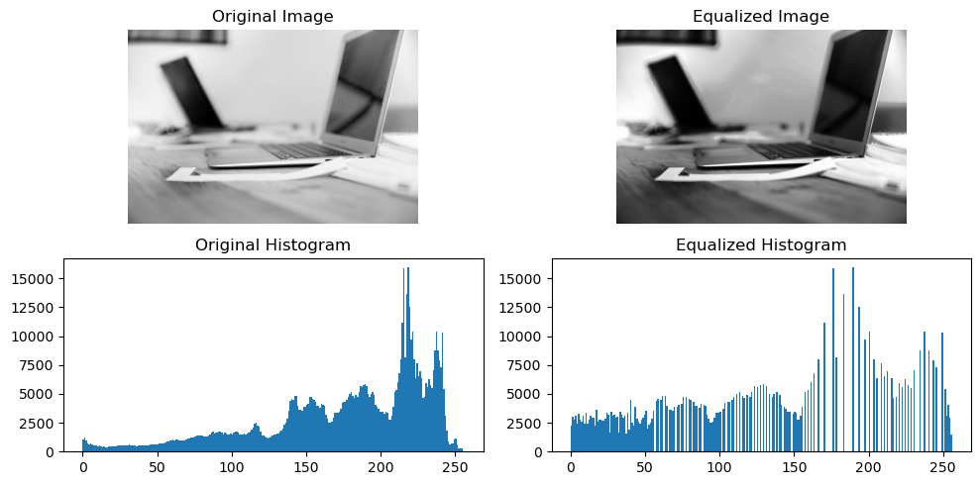

Results:
- Original image shows low contrast with narrow histogram.
- Equalized image shows improved contrast.
- Histogram becomes more spread across intensity levels.

Experiment No-03
Experiment Name: Segment an object from an image using different thresholding techniques:
i) Global Thresholding (Otsu’s method)
ii) Adaptive Thresholding
iii) Compare results and discuss when adaptive thresholding is preferable over global thresholding.
Objectives:
- To understand image segmentation using thresholding.
- To implement Global Thresholding (Otsu’s method).
- To implement Adaptive Thresholding.
- To compare both techniques and analyze their performance.

Theory
Image Segmentation
Image segmentation is the process of dividing an image into meaningful regions (objects and background).
- Converts image into binary form (0 and 255)
- Helps in object detection and analysis

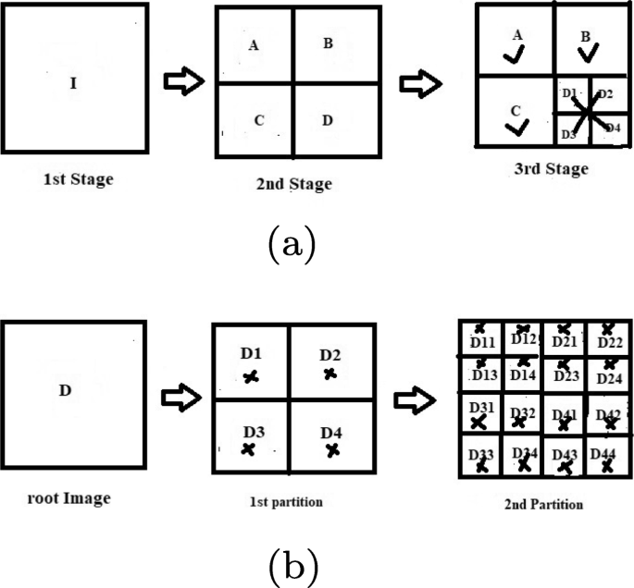

Thresholding
Thresholding is one of the simplest segmentation techniques.
Basic idea:
$$g(x,y)=\left\{\begin{matrix}255 & \text{if }f(x,y)>T \\ 0 & \text{if }f(x,y)≤T\end{matrix}\right.$$
Where:
- $T$= threshold value

Types of Thresholding
1. Global Thresholding (Otsu’s Method)
Otsu’s method automatically calculates an optimal global threshold $T$.
Working Principle
- Assumes image has two classes (foreground & background)
- Finds threshold that minimizes intra-class variance
Mathematically:
$$σ_{w}^{2}=ω_{1}σ_{1}^{2}+ω_{2}σ_{2}^{2}$$
Where:
- $ω_{1},ω_{2}$= class probabilities
- $σ_{1}^{2},σ_{2}^{2}$= class variances
Characteristics
- Fully automatic
- Works well when lighting is uniform
- Fast and efficient

2. Adaptive Thresholding
Adaptive thresholding calculates threshold locally for each pixel.
Working Principle
- Image divided into small regions
- Each region gets its own threshold
- Based on neighborhood statistics
Types:
- Mean method
- Gaussian method
Characteristics
- Handles uneven lighting
- Better for shadows and gradients
- Slightly slower than global thresholding

Differences table:

Feature | Global (Otsu) | Adaptive
Threshold Type | Single value | Multiple (local)
Lighting Condition | Uniform | Non-uniform
Speed | Fast | Slower
Accuracy | Moderate | High in complex lighting
Code:
import cv2
import matplotlib.pyplot as plt

# Load image in grayscale
img = cv2.imread('image.jpg', 0)

# 1. Global Thresholding (Otsu)
_, otsu_thresh = cv2.threshold(img, 0, 255,
cv2.THRESH_BINARY + cv2.THRESH_OTSU)

# 2. Adaptive Thresholding (Mean)
adaptive_mean = cv2.adaptiveThreshold(img, 255,
cv2.ADAPTIVE_THRESH_MEAN_C,
cv2.THRESH_BINARY,
11, 2)

# 3. Adaptive Thresholding (Gaussian)
adaptive_gaussian = cv2.adaptiveThreshold(img, 255,
cv2.ADAPTIVE_THRESH_GAUSSIAN_C,
cv2.THRESH_BINARY,
11, 2)

# Plot results
titles = ['Original Image', 'Otsu Thresholding',
'Adaptive Mean', 'Adaptive Gaussian']

images = [img, otsu_thresh, adaptive_mean, adaptive_gaussian]

plt.figure(figsize=(10,6))
for i in range(4):
plt.subplot(2,2,i+1)
plt.imshow(images[i], cmap='gray')
plt.title(titles[i])
plt.axis('off')

plt.tight_layout()
plt.show()

Output:
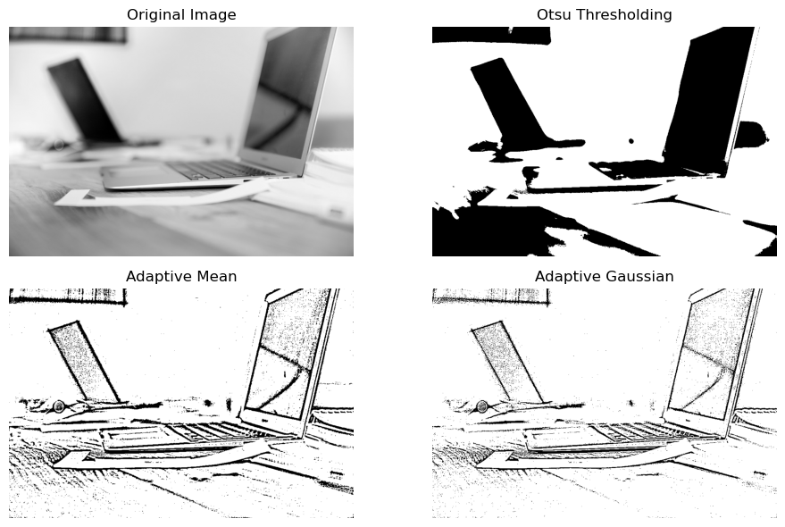
Results:
- Otsu’s method produces a clean binary image when lighting is uniform.
- Adaptive thresholding performs better in uneven lighting conditions.
- Adaptive Gaussian gives smoother segmentation compared to Mean.

Discussion:
Comparison of Results
Otsu’s Thresholding
- Works well when background is consistent
- Fails when shadows or lighting variation exist
Adaptive Thresholding
- Handles brightness variation effectively
- Preserves object details
- Better segmentation in real-world images

When is Adaptive Thresholding Preferable?
Adaptive thresholding is preferable when:
- Image has uneven illumination
- There are shadows or gradients
- Background intensity varies
- Fine details need to be preserved

Experiment No-04
Experiment Name: Load a grayscale image and apply the following edge detection techniques:
i) Sobel Operator
ii) Prewitt Operator
iii) Canny Edge Detector
Compare the results by analyzing the sharpness and completeness of detected edges

Objectives:
- To understand edge detection in image processing.
- To apply Sobel, Prewitt, and Canny edge detectors.
- To analyze edge sharpness and completeness.
- To compare different edge detection techniques.

Theory:

Edge Detection
Edge detection is the process of identifying sharp intensity changes in an image. These changes usually correspond to object boundaries.
Mathematically, edges are detected using image gradients:
$$∇f=\left(\frac{∂f}{∂x} , \frac{∂f}{∂y}\right)$$
- Large gradient → strong edge
- Small gradient → smooth region

Gradient Magnitude
$$∣∇f∣=\sqrt{G_{x}^{2}+G_{y}^{2}}$$
Where:
- $G_{x}$= gradient in x-direction
- $G_{y}$= gradient in y-direction
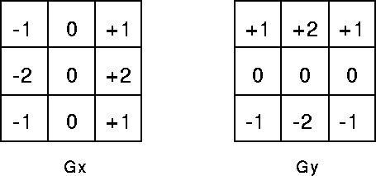
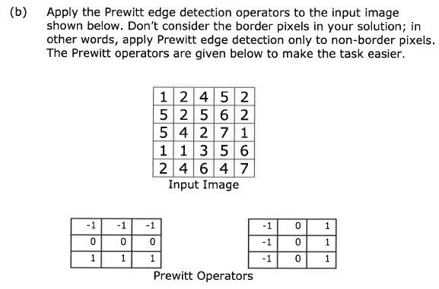

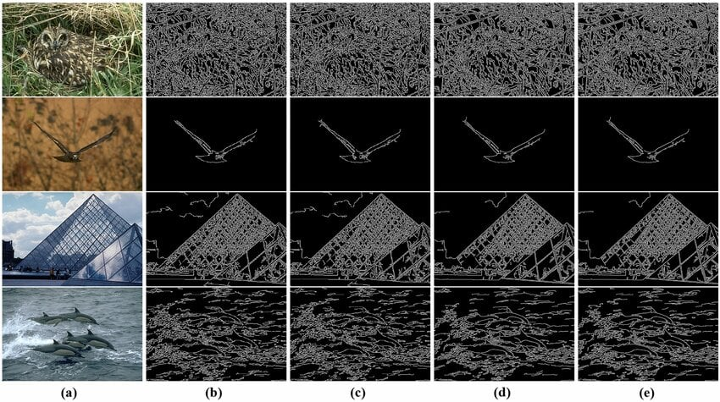

1. Sobel Operator
The Sobel operator uses convolution kernels to detect edges in horizontal and vertical directions.
Kernels:
$$G_{x}=\left[\begin{matrix}-1 & 0 & 1 \\ -2 & 0 & 2 \\ -1 & 0 & 1\end{matrix}\right],G_{y}=\left[\begin{matrix}-1 & -2 & -1 \\ 0 & 0 & 0 \\ 1 & 2 & 1\end{matrix}\right]$$
Characteristics
- Gives more weight to center pixels
- Produces smoother edges
- Reduces noise sensitivity

2. Prewitt Operator
Similar to Sobel but with simpler kernels:
$$G_{x}=\left[\begin{matrix}-1 & 0 & 1 \\ -1 & 0 & 1 \\ -1 & 0 & 1\end{matrix}\right],G_{y}=\left[\begin{matrix}-1 & -1 & -1 \\ 0 & 0 & 0 \\ 1 & 1 & 1\end{matrix}\right]$$
Characteristics
- Simpler than Sobel
- Less accurate
- More sensitive to noise

3. Canny Edge Detector
Canny is a multi-stage edge detection algorithm:
Steps:
- Noise reduction (Gaussian filter)
- Gradient calculation
- Non-maximum suppression
- Double thresholding
- Edge tracking (hysteresis)
Characteristics
- Produces thin and sharp edges
- Detects true edges more accurately
- Reduces noise and false edges

Code:
import cv2
import numpy as np
import matplotlib.pyplot as plt

# Load image in grayscale
img = cv2.imread('image.jpg', 0)

# Sobel Edge Detection
sobelx = cv2.Sobel(img, cv2.CV_64F, 1, 0, ksize=3)
sobely = cv2.Sobel(img, cv2.CV_64F, 0, 1, ksize=3)
sobel = cv2.magnitude(sobelx, sobely)

# Prewitt Edge Detection (manual kernels)
kernelx = np.array([[-1,0,1],[-1,0,1],[-1,0,1]])
kernely = np.array([[-1,-1,-1],[0,0,0],[1,1,1]])

prewittx = cv2.filter2D(img, -1, kernelx)
prewitty = cv2.filter2D(img, -1, kernely)
prewitt = np.sqrt(prewittx**2 + prewitty**2)

# Canny Edge Detection
canny = cv2.Canny(img, 100, 200)

# Plot results
titles = ['Original Image', 'Sobel Edge', 'Prewitt Edge', 'Canny Edge']
images = [img, sobel, prewitt, canny]

plt.figure(figsize=(10,6))
for i in range(4):
plt.subplot(2,2,i+1)
plt.imshow(images[i], cmap='gray')
plt.title(titles[i])
plt.axis('off')

plt.tight_layout()
plt.show()

Output:
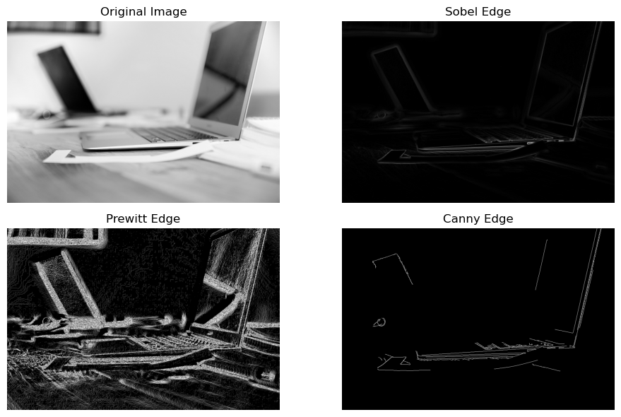

Results:
- Sobel detects edges with moderate sharpness.
- Prewitt detects edges but with more noise.
- Canny produces thin, clear, and well-defined edges.

Discussion:
- Sobel vs. Prewitt: The results are visually similar, but Sobel typically produces cleaner edges on real-world images because its weighted kernel handles variations in pixel intensity more gracefully than Prewitt’s uniform kernel.
- The "Canny" Advantage: Canny is significantly superior in terms of sharpness. While Sobel and Prewitt produce "gradient maps" where edges look like glowing blurs, Canny uses non-maximum suppression to produce thin, precise lines.
- Completeness: Canny's hysteresis thresholding allows it to track "faint" edges that are connected to "strong" ones, resulting in more complete outlines of objects compared to simple thresholded gradient methods.

Experiment No-05
Experimentt Name: Write a Python program to Character Segment of an image.
Objectives:
- To understand the concept of character segmentation in image processing.
- To extract individual characters from an image.
- To apply preprocessing techniques like thresholding and contour detection.
- To prepare segmented characters for further recognition (OCR)

Theory
Character Segmentation
Character segmentation is the process of separating individual characters from a text image. It is a crucial step in Optical Character Recognition (OCR) systems.
- Input → Image containing text
- Output → Individual character images

Steps in Character Segmentation

1. Image Acquisition
- Load image (usually grayscale or RGB)

2. Preprocessing
- Convert to grayscale
- Apply thresholding to create binary image

3. Noise Removal
- Remove small unwanted pixels
- Use morphological operations if needed

4. Segmentation
- Detect contours or connected components
- Extract bounding boxes around characters

5. Character Extraction
- Crop each character
- Store separately

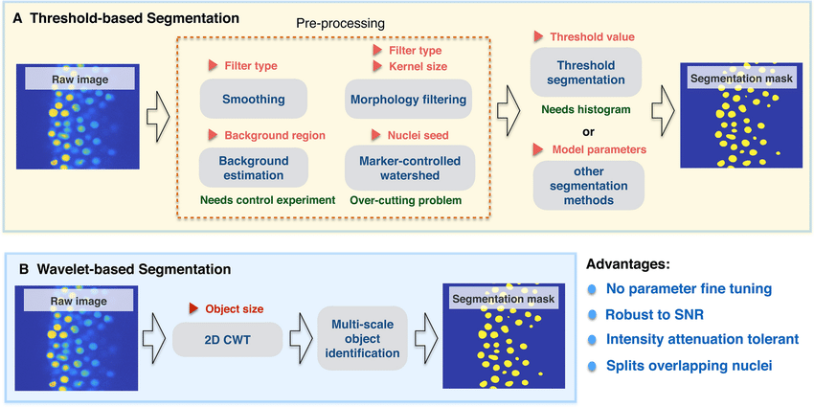

Binary Image Representation
Thresholding converts grayscale image into binary form:
$$g(x,y)=\left\{\begin{matrix}255 & \text{if }f(x,y)>T \\ 0 & \text{otherwise}\end{matrix}\right.$$
This simplifies segmentation by separating foreground (text) from background.

Contour Detection
Contours are boundaries of objects (characters).
- Each character forms a connected region
- Bounding box is drawn around each contour

Code:
import cv2
import numpy as np
import matplotlib.pyplot as plt

# Load image
img = cv2.imread('image.jpg')
gray = cv2.cvtColor(img, cv2.COLOR_BGR2GRAY)

# Apply thresholding
_, thresh = cv2.threshold(gray, 150, 255, cv2.THRESH_BINARY_INV)

# Noise removal (optional)
kernel = np.ones((3,3), np.uint8)
thresh = cv2.morphologyEx(thresh, cv2.MORPH_CLOSE, kernel)

# Find contours
contours, _ = cv2.findContours(thresh, cv2.RETR_EXTERNAL, cv2.CHAIN_APPROX_SIMPLE)

# Sort contours left to right
contours = sorted(contours, key=lambda c: cv2.boundingRect(c)[0])

# Draw bounding boxes and extract characters
char_images = []
output = img.copy()

for i, cnt in enumerate(contours):
x, y, w, h = cv2.boundingRect(cnt)

# Filter small noise
if w > 10 and h > 10:
char = thresh[y:y+h, x:x+w]
char_images.append(char)

# Draw rectangle
cv2.rectangle(output, (x,y), (x+w, y+h), (0,255,0), 2)

# Show results
plt.figure(figsize=(10,6))

plt.subplot(1,2,1)
plt.imshow(cv2.cvtColor(output, cv2.COLOR_BGR2RGB))
plt.title("Detected Characters")
plt.axis('off')

plt.subplot(1,2,2)
plt.imshow(thresh, cmap='gray')
plt.title("Binary Image")
plt.axis('off')

plt.show()

# Show segmented characters
for i, char in enumerate(char_images):
plt.imshow(char, cmap='gray')
plt.title(f'Character {i+1}')
plt.axis('off')
plt.show()

Output:
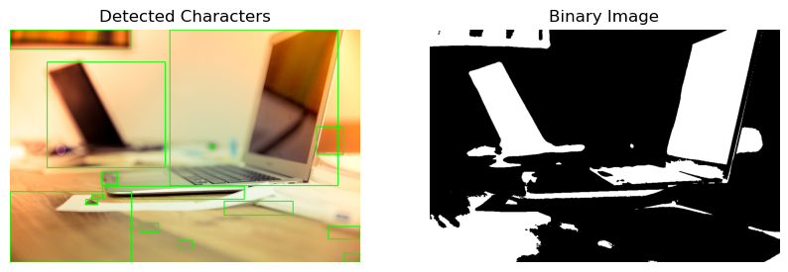

Results:

- The input image is converted to a binary image.
- Contours successfully detect individual characters.
- Each character is segmented and displayed separately.
- Bounding boxes highlight detected characters.

Discussion:
Performance Analysis
- Works well for clean printed text images.
- Segmentation accuracy depends on thresholding quality.

Experiment No-06
Experiment Name: Write a MATLAB/Python program to read ‘rice.tif’ image, count number of rice and display area (also specific range), major axis length, and perimeter
Objectives:
- To read and process the rice.tif image.
- To segment individual rice grains from the background.
- To count total number of rice grains.
- To measure properties such as area, major axis length, and perimeter.
- To analyze rice grains within a specific area range.

Theory:
Image Segmentation
Segmentation separates objects (rice grains) from the background.
- Converts image → binary
- Foreground = rice grains
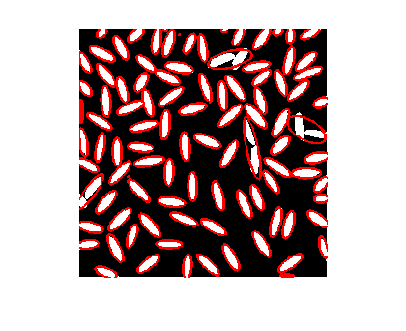
- Background = black
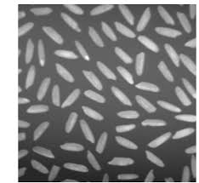

Thresholding
Thresholding is used to convert grayscale image into binary:
$$g(x,y)=\left\{\begin{matrix}255 & \text{if }f(x,y)>T \\ 0 & \text{otherwise}\end{matrix}\right.$$
This helps isolate rice grains.

Connected Components / Contours
Each rice grain is treated as a connected component.
- Each object → labeled separately
- Properties can be calculated individually

Code:
import cv2
import numpy as np
import matplotlib.pyplot as plt
from skimage import measure

# Load image
img = cv2.imread('rice.tif', 0)

# Apply thresholding (Otsu)
_, thresh = cv2.threshold(img, 0, 255,
cv2.THRESH_BINARY + cv2.THRESH_OTSU)

# Invert if necessary (rice should be white)
thresh = cv2.bitwise_not(thresh)

# Remove noise using morphological opening
kernel = np.ones((3,3), np.uint8)
clean = cv2.morphologyEx(thresh, cv2.MORPH_OPEN, kernel)

# Label connected components
labels = measure.label(clean, connectivity=2)

# Get properties
properties = measure.regionprops(labels)

# Count rice grains
rice_count = len(properties)
print("Total number of rice grains:", rice_count)

# Lists to store features
areas = []
perimeters = []
major_axes = []

for prop in properties:
areas.append(prop.area)
perimeters.append(prop.perimeter)
major_axes.append(prop.major_axis_length)

# Display properties
for i, prop in enumerate(properties):
print(f"Rice {i+1}: Area={prop.area}, "
f"Perimeter={prop.perimeter:.2f}, "
f"Major Axis Length={prop.major_axis_length:.2f}")

# Filter by specific area range
min_area = 100
max_area = 1000

filtered = [prop for prop in properties if min_area <= prop.area <= max_area]
print("\nRice grains within area range:", len(filtered))

# Plot labeled image
plt.figure(figsize=(6,6))
plt.imshow(labels, cmap='nipy_spectral')
plt.title("Labeled Rice Grains")
plt.axis('off')
plt.show()

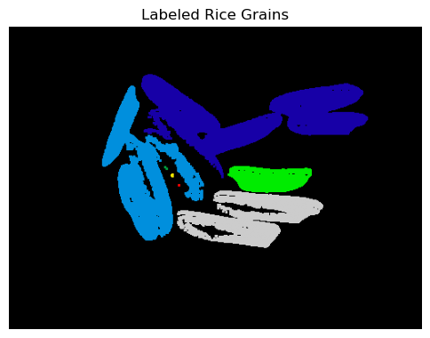
Output: Total number of rice grains: 12

Results:
- The program successfully counts total rice grains.
- Each grain’s area, perimeter, and major axis length is computed.
- Filtering allows selection of grains within a specific size range.
- Labeled image shows different colors for each grain.
Discussion:Works well when grains are clearly separated. Overlapping grains may reduce accuracy.
Experiment No-07
Experimen Name: Write a MATLAB/Python program to read an image and perform convolution with 3X3 mask.

Objectives:
- To understand convolution in image processing.
- To apply a 3×3 mask (kernel) to an image.
- To observe how convolution modifies image features.
- To implement convolution using Python (and MATLAB optional).

Theory:
Image Convolution
Convolution is a mathematical operation used to process images by applying a small matrix (kernel) over the image.
It is widely used for:
- Blurring
- Sharpening
- Edge detection

Mathematical Representation
$$g(x,y)=\sum_{i=-1}^{1}{\sum_{j=-1}^{1}{f(x-i,y-j)⋅h(i,j)}}$$Where:
- $f(x,y)$= input image
- $h(i,j)$= 3×3 kernel (mask)
- $g(x,y)$= output image
3×3 Kernel (Mask)
A kernel is a small matrix applied over the image.
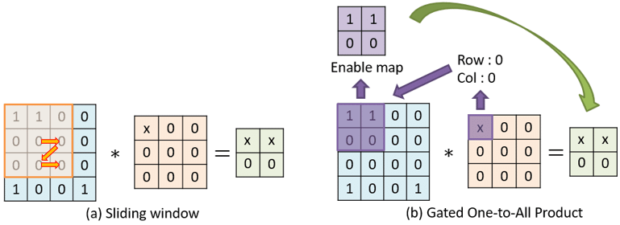

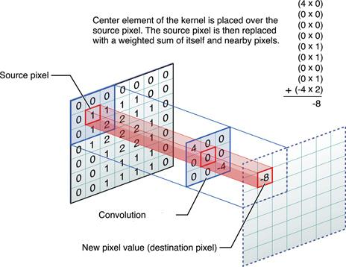



Example kernels:
Mean (Blur) Kernel:
$$\frac{1}{9}\left[\begin{matrix}1 & 1 & 1 \\ 1 & 1 & 1 \\ 1 & 1 & 1\end{matrix}\right]$$
Sharpening Kernel:
$$\left[\begin{matrix}0 & -1 & 0 \\ -1 & 5 & -1 \\ 0 & -1 & 0\end{matrix}\right]$$
Edge Detection Kernel:
$$\left[\begin{matrix}-1 & -1 & -1 \\ -1 & 8 & -1 \\ -1 & -1 & -1\end{matrix}\right]$$

Working Principle
- Place kernel over pixel
- Multiply overlapping values
- Sum results
- Assign result to output pixel
- Move kernel across image

Code:
import cv2
import numpy as np
import matplotlib.pyplot as plt

# Load image
img = cv2.imread('image.jpg')
img = cv2.cvtColor(img, cv2.COLOR_BGR2GRAY)

# Define 3x3 kernel (choose one)
kernel = np.array([[1,1,1],
[1,1,1],
[1,1,1]]) / 9 # Mean filter

# Apply convolution
output = cv2.filter2D(img, -1, kernel)

# Show results
plt.figure(figsize=(8,4))

plt.subplot(1,2,1)
plt.imshow(img, cmap='gray')
plt.title('Original Image')
plt.axis('off')

plt.subplot(1,2,2)
plt.imshow(output, cmap='gray')
plt.title('After Convolution')
plt.axis('off')

plt.show()

Output:
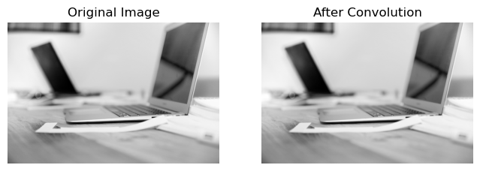

Results:
- The original image is modified using a 3×3 mask.
- Mean filter produces a blurred image.
- Convolution smooths noise and reduces sharp details

Discussion:
Effect of Convolution
- Averages neighboring pixels
- Reduces noise but also removes fine details
Kernel Impact
- Different kernels produce different results
- Choice depends on application

Experiment No-08
Experiment Name: Develop a MATLAB/Python program that performs a two-scale image decomposition using the wavelet transform, and generate plots to visualize the results.

Objectives:
- To understand wavelet transform for image decomposition.
- To perform two-scale (multi-level) decomposition of an image.
- To extract approximation and detail components.
- To visualize different frequency components of the image.

Theory:

Wavelet Transform
The Wavelet Transform is a powerful tool used to analyze signals/images at different scales (resolutions).
Unlike Fourier Transform (only frequency), wavelets provide:
- Frequency + Spatial information

Discrete Wavelet Transform (DWT)
DWT decomposes an image into sub-bands:
At each level, image is split into:
- LL (Approximation) → Low frequency (smooth part)
- LH (Horizontal details)
- HL (Vertical details)
- HH (Diagonal details)
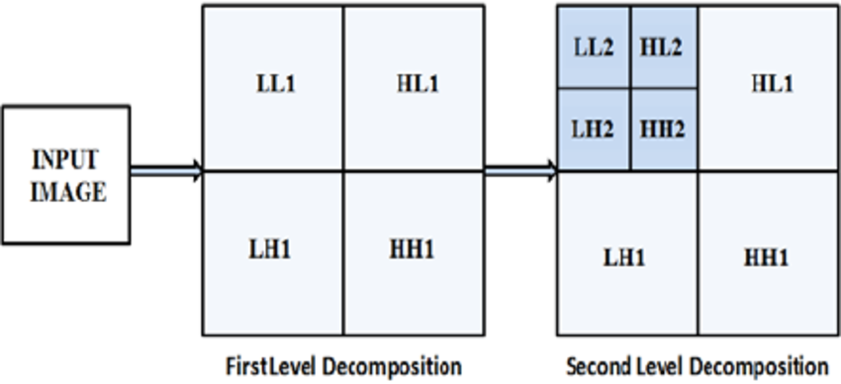
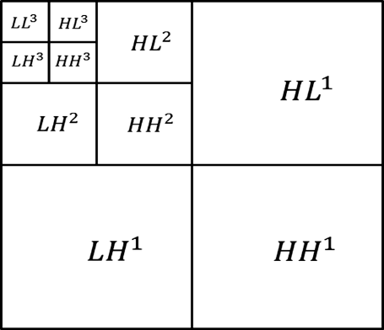

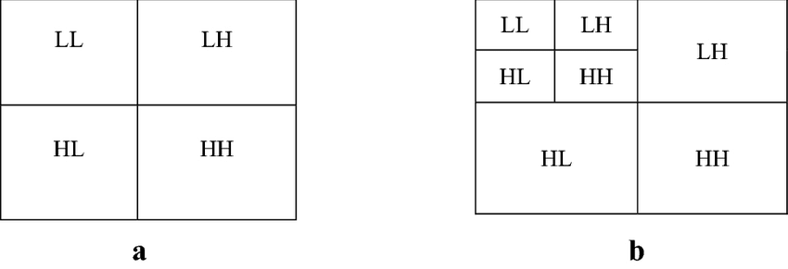

Two-Scale Decomposition
- Level 1: Original image → LL₁, LH₁, HL₁, HH₁
- Level 2: LL₁ is further decomposed → LL₂, LH₂, HL₂, HH₂

Mathematical Idea
DWT applies filtering:
- Low-pass filter → approximation
- High-pass filter → details
Then downsampling is applied.

Code:

import cv2
import pywt
import numpy as np
import matplotlib.pyplot as plt

# Load image in grayscale
img = cv2.imread('image.jpg', 0)

# Perform 2-level DWT
coeffs = pywt.wavedec2(img, 'haar', level=2)

# Extract coefficients
LL2, (LH2, HL2, HH2), (LH1, HL1, HH1) = coeffs

# Plot results
plt.figure(figsize=(10,8))

plt.subplot(3,3,1)
plt.imshow(img, cmap='gray')
plt.title('Original Image')
plt.axis('off')

# Level 1
plt.subplot(3,3,2)
plt.imshow(LH1, cmap='gray')
plt.title('LH1 (Horizontal)')
plt.axis('off')

plt.subplot(3,3,3)
plt.imshow(HL1, cmap='gray')
plt.title('HL1 (Vertical)')
plt.axis('off')

plt.subplot(3,3,4)
plt.imshow(HH1, cmap='gray')
plt.title('HH1 (Diagonal)')
plt.axis('off')

# Level 2
plt.subplot(3,3,5)
plt.imshow(LL2, cmap='gray')
plt.title('LL2 (Approximation)')
plt.axis('off')

plt.subplot(3,3,6)
plt.imshow(LH2, cmap='gray')
plt.title('LH2')

plt.axis('off')

plt.subplot(3,3,7)
plt.imshow(HL2, cmap='gray')
plt.title('HL2')
plt.axis('off')

plt.subplot(3,3,8)
plt.imshow(HH2, cmap='gray')
plt.title('HH2')
plt.axis('off')

plt.tight_layout()
plt.show()

Output:
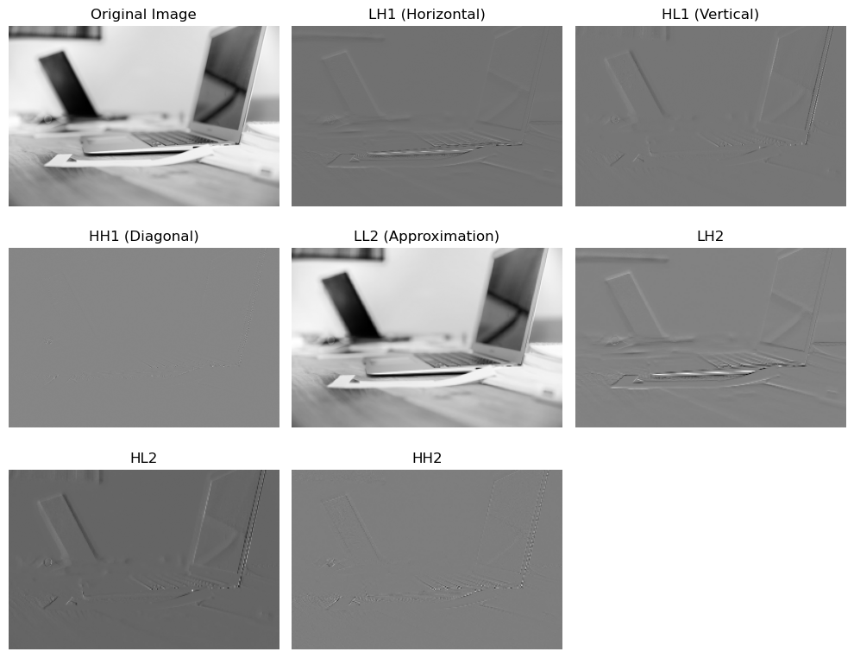

Results:
- The image is decomposed into multiple frequency components.
- LL shows smooth structure of the image.
- LH, HL, HH show edge details in different directions.
- Second-level decomposition provides finer analysis.

